NEWSLETTER NOVEMBER 2022 NO 188

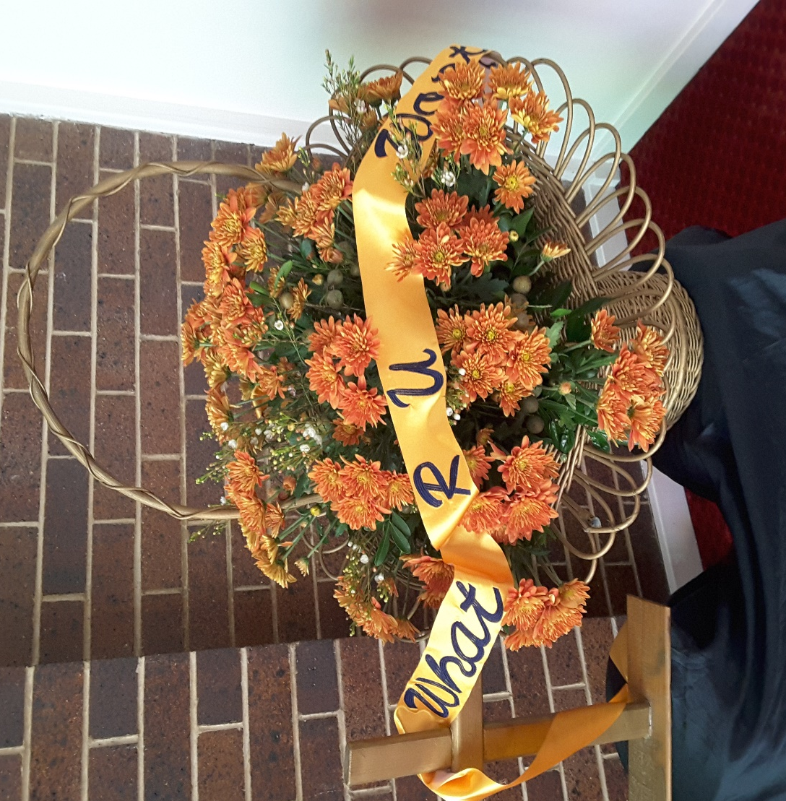

What R U Worth?
So don’t be afraid; you are worth more than many sparrows
Matthew 10: 31

LWQ FRIENDSHIP DAY 21st May 2022
St Paul’s Lutheran Church Toowoomba

‘Women loved by God, sharing this love with others’.
FRIENDSHIP DAY SATURDAY 21ST MAY 2022 – HOSTED BY DDZ
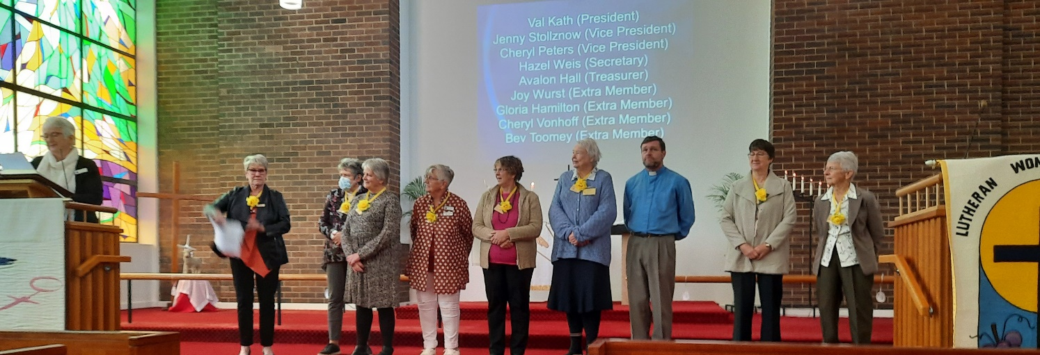
The quintessential Toowoomba weather of fog, drizzle, wind and cold did nothing to dampen the spirits of the 76 attendees to Friendship Day (although unfortunately, one did suffer a severe asthma attack and had to go home early to recover in the warmth of her own home). Ladies (and gentlemen) basked in the glow from the beautiful stained glass windows of St Paul's while the absolute warmth of being able to gather together as Lutheran Women of Queensland after such a long absence, was felt by all. Friendship Day was held as a one day gathering in lieu of our (previous) weekend Retreats as a way of getting together around all the restrictions. We opened with the sharing of Holy Communion and a better understanding of the context of Matthew 10 and Gods intention in regard to our worth through the analogy of the sparrow in the market place, as Pr Mark Demmer led us in our Service and Bible Study. (Pr Mark is the serving pastor at St Paul's and the DDZ Spiritual Advisor)
Members of host Zone, Darling Downs (who were easily identified in their bright gold neck attire), were introduced in a novel LEFT / RIGHT fashion by Newsletter editor, Pam Flesser. We were privileged to have Maureen Turner (LWA Vice President and co-editor of our Lutheran Women magazine) present & deliver news and greetings on their behalf. Greetings and welcome were also extended from Shirley Horrigan (LWQ President), along with several personal and other States greetings.
Attendees were treated to many warming cuppas and time to catch up; singing praises; two Guest Speakers; and various fun activities from finding out how 'observant' we are to identifying various smells and seeds.
Pr Simon Mackenzie (Goombungee/Maclagan Parish) spoke on his years serving in mission in Thailand; while also drawing on the days theme in quoting from a certain 'claimed world historian' who predicts the possible end of mankind as machines will make humans obsolete! He reinforced 'DO NOT FEAR', we are wonderfully made in the image of God, treasure what we have.
The Offering of $1105 to go to LCA International Mission, earmarked Thailand.
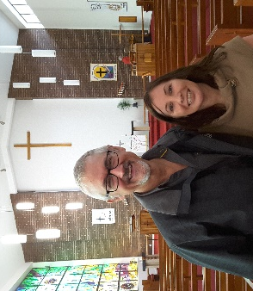
Cath Zarnke (St John's/Glencoe Parish) gave a brief rundown of what may be in store for her as she is about to embark as an English lecturer to Martin Luther Seminary in Lae, PNG.
Past staff member and Director from the Googa Outdoor Education Centre, Brad Teakle (St John's/Glencoe Parish) shared many antics and stories of personal growth and non-committal as Grade 10 students participate in a four week outdoor education program. This is in the simplistic 'style of yesteryear' ie no mobile phones, electricity or family contact, while participating in hiking, camping, daily farm chores, cooking over open fire etc. Googa is situated in the Blackbutt Ranges and their mission statement is 'growing deep in community in Christ' - this is reiterated by the skills learnt along with the personal and spiritual growth.
Brad lead a Closing Devotion followed by singing with the video theme song “My worth is not in what I own” (by Keith & Kristyn Getty) and the Christmas Blessing.
After the conclusion of the days program, many regathered (with husbands in tow), to enjoy another catch up over wine and nibbles. Dinner and dessert were served while savouring background music, witticisms and a competitive round of 'Christmas Songs' Bingo. The comradery and the chance to finally 'catch up' was felt and experienced by all

All praise and thanks to God. Reported by Avalon Hall

LWQ CENTRAL ZONE RALLY/FELLOWSHIP WEEKEND 2-3rd April 2022
Hosted by Biloela Parish Women: Theme song: “Teach me to dance, to the beat of your heart”
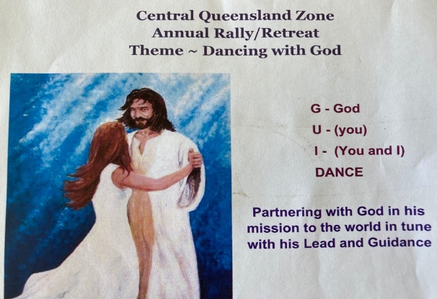
The Rally with a difference. Before the 2nd April, it was a Start, Stop, and Start, beginning. START - our conscientious Zone President comes to the rescue, she will pick up the ordered food from the various shops on her way to Rally, and call on the Martha’s present to help prepare & serve the food. We gathered at Banksia Place, Redeemer Lutheran School, Biloela at 8.30am for our welcome cuppa, & registrations, most of us oblivious to the happenings of the past couple of weeks. The theme for the day was also different to most themes I have gathered under during my walk in LWQ. WELCOME: Zone President, Dianne Krenske welcomed all including local member, Cathy Wissemann, LWQ State President, Shirley Horrigan, Visitors from WBBZ, and also our sisters from Mackay who faithfully continue to support our Zone.
Opening Devotion: Led by Pastor Graham Pfeffer was based on the theme. The song “Lord of the Dance” was sung. Have you ever wondered what the dance is in this song? “Lord of the Dance" tells the gospel story in the first-person voice of Jesus of Nazareth with the device of portraying Jesus' life and mission as a dance. Dancing is mentioned often in the Bible and is used throughout the Old Testament as a means of worship and praise to God. Therefore, along with having that desire to worship and dance with joy at what God is doing in your life, we are going to see how God wants us to take his hand and let him lead us in the dance of his life and mission. Election of Office Bearers: Dee Challenor Pres. & Carolyn Murdoch Vice Pres. were elected. Other office bearers remain the same.
Reports: - State President, Shirley Horrigan was glad of the opportunity to attend our Rally and enjoyed the trip up, seeing different parts of the country. Shirley explained, that she and Wayne had barely been out of Dalby since COVID started & their 4 day break, was a very pleasant little holiday for them. Shirley informed us about the upcoming Friendship Day, in Toowoomba in May.
Emerald, Gladstone & Rockhampton, all managed to do a small amount of fund raising, in between COVID lock-downs. Christine Pukallus spoke on the Devotional book “Rural Reflections” which is a project of St John’s Lutheran Church, Emerald. The project was inspired by Pastor Stephen Jaensch due to the ongoing drought. It is a collection of short, devotional reflections written by Pastor Steve, members of the St John’s congregation and other Christians in the area. Proceeds from this book have been used to support mission projects etc.
Bible Study: led by Pr Graham. Being brought up in a home where my father was dead against dancing, I’ve found it hard over the years to accept the concept of dancing as a worship & praise tool to God, but it certainly is. When a man and a woman prepare to dance in ballroom dancing, the man puts his right hand behind his partners back. He holds out his left hand inviting his partner to put her right hand in his & places her left hand on his upper arm. He becomes the leader, and they dance as one. When we consider the song, Lord of the Dance, where the dance is the life and mission of Jesus, how are we being partnered and guided in the dance?
As a partner with Jesus, we show a willingness to be attentive to his gentle guidance in our life of faith with Jesus as the Lord of the Dance. Are we ready for him to lead and guide us through the dance floor of life? Are we always ready to follow God, feel his hand on our back, as we take his hand and submit to his will? Jesus said, “I am the resurrection and the life; he who believes in Me will live, even if he dies, and everyone who lives and believes in Me will never die. Do you believe this?” (John 11:25-26). It is crucial for your life and salvation to take the hand that is held out for you to join in the dance. Believe that the dance that God and Jesus performed was the perfect dance with all the right moves to turn your mourning into dancing. It’s the dance from death to life.
Singing songs of praise: Teach me to Dance, Take Thou my Hand and Lead Me, Take my Life and Let it be…were fitting songs. A delicious luncheon was served & enjoyed by all. Thanks to all ladies who pitched in. Julie Krause spoke about the doings of ALWS. ALwayS for those forgotten by the world. In the dance of life, she has received blessings for a new life & an opportunity to serve the forgotten in the world. Julie spoke of the many countries, where ALWS is serving and urged us not to forget the suffering but to pray always.
OFFERING for the day of $1,288.50 goes to Penny, infant daughter of Kylie Leonard who has been the Cheer and Dance teacher at Redeemer Lutheran College in Biloela since September 2014. Kylie writes: Our beautiful Down Syndrome daughter Penelope, was born in January. She had a rough start at the beginning and needed to go on oxygen and a feeding tube in her first week. It was then that her heart condition was discovered, and we were rushed by the RFDS to the Queensland Children’s Hospital. We spent close to four months in hospital while Penny received a VSD repair to her heart and throat surgery to assist her airways and breathing. She continues to battle with breathing and viruses. It is so wonderful to have the prayers and support of our local Lutheran community.
LWA Project - ALWS - Tonga $1528.15 was raised for the year. It is with regret, the Zone accepted Biloela’s information, that they will no longer be able to host Rally weekends, as there is becoming less and less women, to do the organising and work. This will leave only 3 guilds in the Zone to host Rally Days and they are Gladstone, Rockhampton & Emerald.
Our day closed with a devotion, followed by afternoon tea.
Because of COVID, the planned evening programme was spent at the RSL We had the room to ourselves. Everyone enjoyed this special time, chatting & catching up with friends. Luncheon after the 10.30 morning service, concluded the weekend, which I’m sure was enjoyed by all despite, having to take a few detours from the main course.
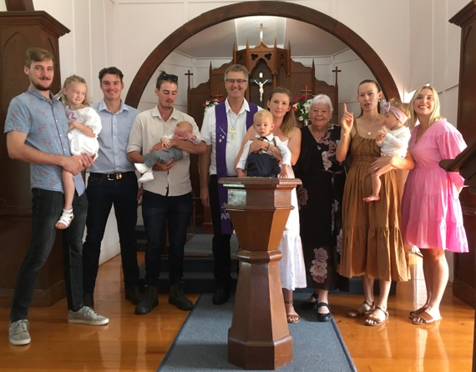
P.S. Please allow me the space, to tell why I was unable to attend the morning service in Biloela and had to get back to Theodore for 8am Service, for a very special dance with God. Through dancing with Pastor Graham & myself at different times, our granddaughter-in-law, who says, she had never heard of God or Jesus before she met Lachlan (our grandson), about 7 years ago, had reached the point, that she wanted along with their 3 children to be baptized. Oh, glorious day. This was to be Pastor Graham’s 3rd last service in our parish. As I write this, my heart still dances with joy, that she, has come thus far. I had the honour of being her Godmother plus another younger person, after I explained to her, I mightn’t be around many more years, to encourage her in her dance with God. I am loving this dance, as I see her faith grow & she becomes more conscious of God leading her in her life. A lot of dancing to do yet, but the first steps have been learnt. Praise God.
Reporter: Kathy Kucks

IMMANUEL ROPELEY LUTHERAN LADIES’ GUILD TURNS 75
Members of Immanuel Lutheran Ladies Guild Ropeley celebrated 75 years of faithful service to their Lord and their church on Sunday 22nd May 2022. A special church service was held with Pastor Jing Luan officiating. A processional with the crucifier holder, Shae Burchmann, Pastor Jing and the present Ladies Guild members entered the church. Pastor Jing’s sermon spoke about God doing good things every day and today was the celebration of the 75 years of Ladies Guild Immanuel Ropeley.
Members of the local churches, from Ropeley, Laidley, Lockrose, Gatton and invited guests including Mrs. Shirley Horrigan President of LWQ attended the service. Shirley congratulated the Guild on their achievement and celebration.
After the service, an excellent hot meal was served courtesy of the Ropeley Ladies Guild. The hall decorated with memorabilia photos, white table clothes and red serviettes where much reminiscing went around the tables and Shirley Reimann had us in fits of laughter with her jokes.
The very first meeting of the Guild was held on May 25th 1947 with 21 ladies meeting (and as was the custom back then, all dressed in hats and gloves). At the second meeting, 40 financial members attended. Fees then were one shilling (today the fees are WMZ $2.00, LWA $5.00. LWQ, $4.00, LWA Magazine $14.00, LWQ Newsletter $4.00). Secretary of the present Immanuel Ropeley Ladies Guild Mrs. Shirley Reimann’s mother was a foundation member. Shirley is a strong advocate for the small guild of six current members. Shirley made the statement “I wonder if all those lovely, devoted ladies who were foundation members of our guild even thought that 75 years on, some of their descendants would be celebrating this milestone anniversary”.
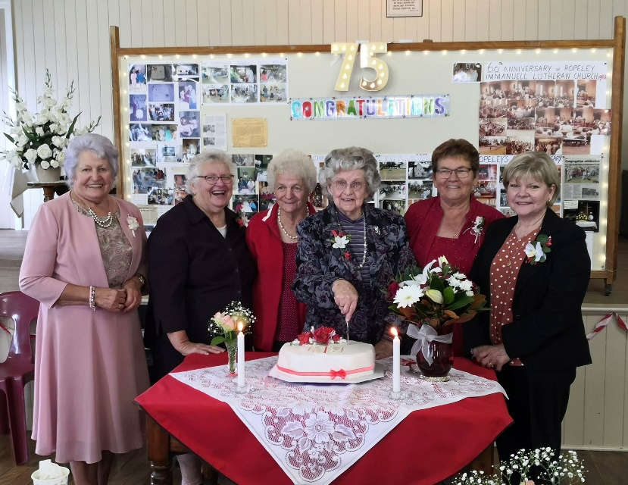
The Ladies work extremely hard for their small congregation, catering for many funerals, catering for Faith Lutheran College Plainland senior classes, Good Sarmatian shoe boxes for Christmas for those countries less fortunate than ours. The ladies also support the aims of Lutheran Women of Australia and Lutheran Women of Queensland.
L-R Shirley Reinmann, Lyla Biegal,
Elaine Krenske, Val Dodt,
Lorraine Smith, Robyn Dodt

Ladies of Ropeley, we applaud you for your dedication and diligence in serving your Lord and your church over many years, congratulations.
We look forward to the 100th Anniversary of Immanuel Ropeley Lutheran Church Sunday 5th February 2023. Service 9.30 am
As president of West Moreton Zone, I commend you on your dedication over the years and a big congratulations for all the work you have done and continue to do. Your faithful meeting around God’s word each month shines your light in the Ropeley district. May God hold you all in the palm of His Hands.
Reported by: Shirley Klinge - President West Moreton Zone.

LWQ WEST MORETON ZONE 54th ANNUAL RALLY – 31st MAY 2022
Our hosts, Trinity Women’s Guild Boonah, warmly greeted us with a delightful morning tea and a display of a most amazing array of quilts, and artworks crafted by many of
“God’s Gifted People” (1 Corinthians 12:7)
Boonah Guild members opened our Rally with a clever skit, using stick puppets to depict our different body parts. The narration made it very clear that any one part of our body doesn’t function well without the other. Each one of us has been blessed with abilities that we all need to recognise, use and share with each other to grow God’s church. Shirley Klinge, WMZ President, and Faye Gutzke Boonah President, welcomed 22 members, Pastors Peter Geyer and David Schmidt and 6 visitors to Dugandan. Visual display was a painting of a Sunflower. Painted by Maureen Itzstein. We were likened to the petals on that impressive artwork. Just as many parts make up a body, so many petals complete the sunflower. The Holy Spirit shines gifts, talents, thoughts and energies on us “petals” that we are to use for good so that all things will flourish and give Glory to God. Guest speaker Dr John Osgood, a retired medical practitioner, has as a Christian professional, always had a passion for Bible history. An accomplished speaker and author of several books, he kept us spellbound. He has researched extensively the history of the nations from a Biblical perspective. Dr John took us on a journey from the period after the global Flood at the time of Noah, to the dispersion of the people groups after the Tower of Babel. Using what is written in the Bible, combined with archaeology and modern genetics analysis, he traced how the Aboriginal people of Australia came to this land, crossing land bridges caused by lower sea levels at a time of a Great Age. When we start with the Bible and the time-line Dr John presented, the evidence supports what the scripture clearly presents. We were all affirmed and encouraged in our faith to have these things clearly explained to us. Dr John was presented with gift of appreciation.
We thank Pr. David Schmidt for sharing this day with us and presenting the Bishop’s message based on John 14:27 - “Peace I leave with you, my peace I give to you.” Don’t let our hearts be troubled, find peace in every situation. All reports were accepted. Our offering of $567.00 was directed to Qld District Disaster Fund, for Flood Relief.
As her final duty as Zone executive member before retiring after 29 years of service, Dawn Heck moved a vote of thanks to our hosts, Pastors, President Shirley (8 years of service), Jan Fischer (retiring after 8 years of service as Secretary and 7 years as Treasurer), guest speaker, book of reports authors and organist Joyce Damm, who accompanied us as we sang with gusto the hymns chosen for the day and wished all safe travel to their homes.
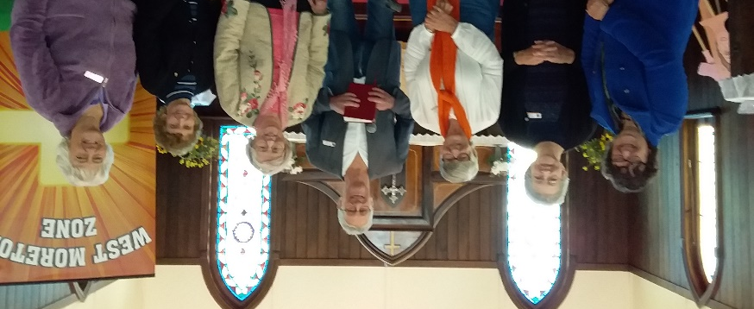
Zone Spiritual Advisor, Pr. Peter, installed the Executive for 2022-23 and concluded the day with devotion. A video featuring many famous people who had been advised, in their formative years, that they were “not capable of accomplishing anything” had succeeded despite the prediction reminding us that we have God given talents that should not be ignored. Gifts of the Spirit are as numerous as we are as Christians. What are our talents? We need to identify and use these gifts. We all have a role to play. There are many different ways of serving, but the same Lord is served. Pres. Shirley presented gifts to both Dawn and Jan acknowledging their many years of dedication and faithful service to the West Moreton Zone. After singing “Bless our Food’ we enjoyed lunch and fellowship. A blessing we truly appreciate and value now the restrictions of the pandemic have eased.

L-R: Wendy Paech, Shirley Meier,
Shirley Klinge, Rev Peter Geyer,
Faye Gutzke, Maureen Itzstein,
Delma Barrett.

Reporter - Jill Manteufel

ST MARK'S CALOUNDRA LADIES FELLOWSHIP
CELEBRATES 50 YEARS 1972 – 2022 on Wed. 6th July
April 1972, Tess Drew was inspired to call a group of 8 ladies together to discuss the formation of a Ladies Guild, which was formed in May and the first official meeting was held on 18th July 1972. Pr. Martin Prenzler chaired the first meeting. President Tess Drew, Mrs. Lowe Vice President, Mrs. Conway Secretary, Mrs. Pfieffer Treasurer, Mrs. Borm Auditor. 15 members were listed as foundation members. Membership fee was $1.00, a plate was placed on the table for offerings which still continues to this day. The Fellowship became affiliated with Brisbane North and Sunshine Coast Zone later in the year.

The format established for each monthly meeting was a hymn, devotion and Bible Study led by a Pastor. This format still continues today with morning tea, recognition of member’s birthdays and a small business meeting added.

Since those early years the Ladies of St Marks have always been a very active and enthusiastic group within the church and wider community. Over the years they have raised funds by way of street stalls, pie and lamington drives, cake-less cake stalls, car boot sales, recipe books and also helping with the annual Bargain Bonanza. These monies raised enabled donations to be given to St Mark's for various items. Sunday School materials, blinds for church windows, ceiling fans, 2 folding tables, 5 large print hymn books. In 1989 purchased a refrigerator, stove and pantry for the kitchen. They continued to help St Mark's with donations for carpet, bibles and chairs. Because St. Mark’s Church is relatively new (50 yrs.) and a small congregation, these items were all donated by the Fellowship. Not forgetting the local community, the Ladies donated money to Meals on Wheels, Immanuel Gardens Retirement Village plus knee rugs, Community bus, Mary and Martha's. Also had a morning tea for Blue Nurses and raised $300.00. In the later years donations have continued to Australian Aboriginal Missions, Zone projects and overseas Mission work through the ALWS. Replacement items in St Mark's church for their 50th anniversary and new Bibles. Visiting members in hospital, shut-ins or phone calls are part of our mission work

Being members of the BNSC Zone, St Marks' have been part of and hosting Annual Zone Rallies and Fellowship Days. Attending LWQ yearly Retreats and Conventions. St Mark’s Ladies Fellowship have been a part of the World Day of Prayer and Interchurch Fellowship with other churches in Caloundra.

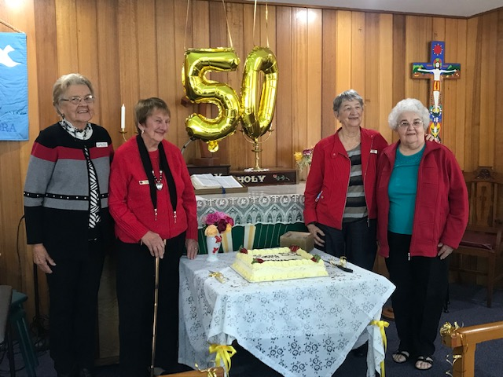
St Mark’s Ladies Fellowship have celebrated 25, 30, 40, 45 and now 50 anniversaries. In closing we thank Edna Leacy for making the altar cloth. I wish to acknowledge long standing Committee members of St Mark's Ladies Fellowship Lorna Bausch President, Vi Lange Secretary, Joan Gaedtke Treasurer who have each served 20 years in their respective roles. Lorna Bausch who made all the banners for the church seasons and more recently Val Denmar and helpers making new paraments for the church seasons. We have celebrated special birthdays,
Anna Gramenz 100 years, Pearl Harvey 90 years, Phyllis Schultz 90 years and June Elsner 90 years. I thank God for being part of the Ladies Fellowship over the years.
Cutting the Cake: L-R: Lorna Bausch, Pearl Harvey, Joan Gaedtke, Naomi Bruggemann.

Psalm 197:1 "Give thanks unto the Lord, for he is good, his love endures forever."
Narelle Jefferd President

BRISBANE SOUTH & GOLD COAST ZONE LUTHERAN WOMEN OF QLD

54th Rally Day: Monday 4th July, 2022
Theme: Silver & Gold

Surely there is a mine for silver, and a place for gold which they refine. ... For there is a place for the silver, whence it comes, and a place for the gold, ... They tunnel through the rock; ... their eyes see all its treasures. Job 28:1,10
Approximately thirty people eagerly arrived on a chilly, cloudy morning at Good Shepherd Church, Tingalpa to be greeted by the shining faces of the host ladies with a warm welcome to their premises which were delightfully decorated with gold and silver flower arrangements, a gold and silver decorated cross and church paraments with tables and balloons all emanating our theme of the day. What a joy was planted in our hearts!
Our awesome God was praised enthusiastically in the singing of that beautiful hymn: “How Great Thou Art”. Pr Rob D’Antoni was our shepherd for the day as well as our guest speaker. In the morning devotion he asked the gathering: “What did you bring today in your gold and silver adornments” and then “What did God bring today” closing with the statement “God brought YOU today – because you are His greatest treasures, more precious than silver and gold and his greatest possessions”. Pastor told of his life’s journey in the lead, silver, zinc and copper mines of Mt. Isa. He kept us amused with his stories of life below the surface, about trust in the Lord when everything is out of your control, how God equips you for a purpose and protects you in times of danger. His walk with the Lord has been a calling he received as a child but only acted upon as an adult during his time with the Lutheran church in Mt Isa. He was thanked for such an inspirational sharing of his life with a gift voucher from the zone.
Three proposals were presented and carried. Our offering for the day of $480 was given to the ALC Pastoral Assistants Fund; $2500 from Zone funds was donated to ALWS and our Zone project for this year is Lutheran Media. We were fortunate to view an encouraging power point presentation from ALWS and a personal heartening video to us from Lutheran Media. Our zone executive remains unchanged for a further year consisting of Naomi Marks, Sharon Tegan, Leanne Kopp-Verdier, Kaye Rossmann, Colette Mangan and Shirley Hardke.
We now have 88 financial Zone members. COVID interrupted our gatherings over the past year causing a fear of mingling, but the chatter and laughter proved that the spirit of the Lord was present in our hearts and being freely shared in blessed fellowship. Tingalpa ladies are to be praised for their wonderful food, trading table and hospitality that touched the hearts of us all.
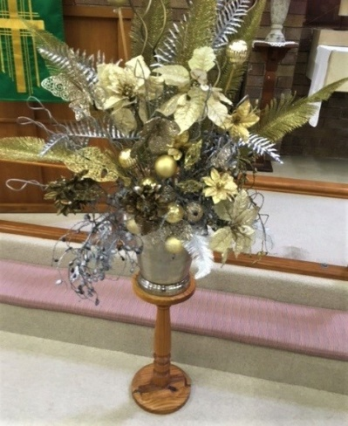
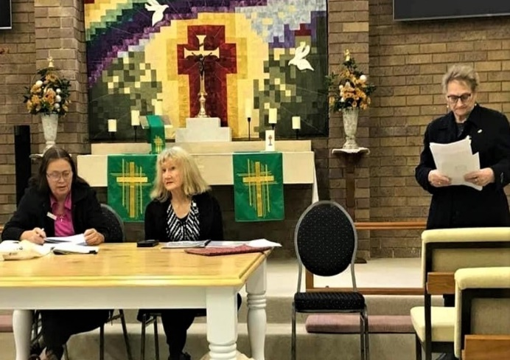
All praise to God for each one who is his treasured possession – more important than silver or gold!

Reported by:
Kay Rossmann

S̄wạs̄dī, hello!
My name is Elsa Matthias. I am 22 years old and I represent the Lutheran Church of Australia and New Zealand (LCANZ) within the Global Young Reformers Network (GYRN) of the Lutheran World Federation. From the 18th to the 23rd of May, I had the privilege of attending the Asian Church Leaders Conference in Thailand on behalf of the LCANZ and the Asian GYRN. Thailand is home to beautiful people and is rightly nicknamed the Land of Smiles. Although these are sometimes difficult to see during our current pandemic climate. Over the course of these 6 days I was able to listen to and learn from this wonderful church, see some of the works that they are doing within their community, and discuss with their leaders how the Lutheran Church can continue to influence the communities around us.

In Thailand, only 1.13% of the population belong to Christianity, with even fewer belonging to the Lutheran church. Yet, this small percentage of the population are very active in the pursuit of God’s mission. The recently elected Bishop Chanda described some of the mission works; including the Home of Grace, and the Immanuel orchestra. The Home of Grace is a safe place where pregnant women in unfortunate situations can go. These women are protected and looked after when they are most vulnerable. They are also given the opportunity to help create giftware that can be used to fundraise and support the Home of Grace. At the conference, the team from Home of Grace brought some of this giftware to sell and share with the attendees of the conference.

The Immanuel Orchestra provides scholarships for young people to learn and perform music. They give back to their community by playing in church functions and even as the church music group for the Sunday worship service. The lead viola player, now has graduated from his studies, but continues to support and lead his colleagues within the Immanuel orchestra.

The Lutheran Seminary is attached to the head church within Bangkok. Though we were not given the opportunity to attend the seminary, we were able to visit the church for Sunday worship. The church is a vibrant space, boldly coloured in red, blue and gold. It wasn’t always! When the church first opened, all of the walls were tan, white and brown colours (what you would typically see within a western church building). The Thai people decided to take ownership of their own space of worship and the students of the seminary spent many weekends hand painting their church. It is beautiful and a wonderful way to work together as a community to honour God.

The COVID-19 pandemic has made challenges for God’s people throughout the world. The Asian Church Leaders Conference provided a space in which church leaders from the entire region could meet together and talk about ministry as it occurs after the storm. Responses to the storm included hybrid worship services, in which some of the community attends in person and others attend online. Church leaders discussed how they created worship materials and support baskets to deliver to the members of their church required to isolate and therefore unable to get food. Though a challenging time for all, the COVID-19 pandemic also provided a space where the people of God could share his love.

The Thai people were so welcoming as they shared their church and their culture with us. I pray for the continued growth of the Thai church and protection over their people. I pray for the new Bishop Chanda Saiyota as he continues to lead these beautiful people. May their ministry be blessed as the storm continues.

I have been blessed to meet these people and I hope hearing some of the stories of their mission works is a blessing to you.

Elsa Matthias (Granddaughter of Judith Smyth)

Darling Downs Zone Fellowship 2022.

Haden Fellowship President Dianne Brown and Crows Nest Parish Chairman, Glen Voll welcomed 37 ladies, 6 visitors and 4 Pastors to St. Luke’s Crows Nest under the theme “Stepping into Spring”.
Pr Mark Demmer led us into the day with a devotion based on Zechariah10:1 “Ask the Lord for
rain in the springtime. It is the Lord who makes the storm clouds. He gives showers of rain to men and plants of the field to everyone.” Since the end of last year God sent rain in abundance,
compared to previous years, and what a difference rain makes seeing dams being full, springs
flowing and green fields once again. He has renewed our land just in the same way He renews us through the waters of our baptism and through hearing his word daily. He will always see us
through bad and good times and always bring us back into His fold when we go astray, for God’s
love is always there in abundance for us.

Pr Dylan Miegel brought us further in depth with bible study of God’s abundant love through
righteousness and justice in several passages from the book of Isaiah. Closing with the words ‘So intent is God to establish a garden, so intent is God to bring justice and healing to the nations, that no human sin can stop his plan. Those who have been sealed by his name through the waters of baptism will be brought through their trials to behold the stream of living water from God’s throne and through his garden. It is there that humanity will once again share in God’s joy for all things living.’

A registered nurse, an active member in the Crows Nest Show Society and a mother of four,
Jessica Hansen our guest speaker, saw her way of helping and rejuvenating/brightening up her
community through her experience in 2007 ABC Heywire. Through Heywire she learnt how grants could benefit her vision of brightening up the blank walls of the local show pavilion. In 2019 the Australian Government had grants going for rural areas, hopefully that would fit the bill for her project. After three times applying she was successful, enabling her to engage a Mongolian street artist Heesco (Khosnaran Khurelbaatar) to carry out the project of painting three walls of the Pavilion depicting the cultural and local attributes of the Crows Nest community.

Qld ALWS rep, Pr Martin Scharnke gave a report on the refugee crisis in Ukraine, Myanmar,
Bangladesh, Afghanistan, Pakistan, Kenya and Somalia. Large percentage of refugees are women and children. Monies can be raised by participating in ‘Walk My Way’ and through Gifts of Grace Pr Nathan Glover updated us on vacancies and installations around Queensland.

Pastor Martin Scharnke closed the morning with a devotion based on Ephesian2:10 ‘Each of us
are God’s handiwork to do good works and spring into some joy as we do His work’.

Reporter: Cheryl Peters.
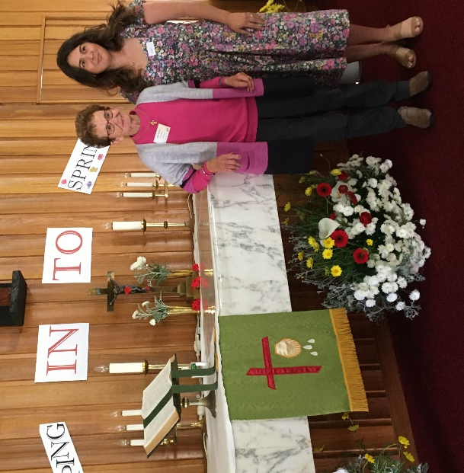
FLORAL DISPLAY EXPLANATION:
Liesel Vonhoff explained the symbolism of the colours used by her and her Grandmother's (Joan Vonhoff) floral display featuring green for the sign of growth, life and hope; red for Jesus' blood that was shed for us; white to show that Jesus has washed away our sins and yellow for God's radiant glory…
Picture: Joan and Liesel Vonhoff
(Hazel Weis from Minutes)

WEST MORETON ZONE FELLOWSHIP DAY 27September 2022
The 54th Annual Fellowship day was hosted by Peace Lutheran fellowship at Peace Lutheran Church Gatton.. 37 in attendance including 3 pastors and 5 members of the God Squad. Theme for the day “Working for God” based on Ephesians 2:10. “God has made us what we are and in union with Christ Jesus, He has created us for a life of good works, which He has already prepared us to do.” A delicious morning tea, served under the awning of the driveway was enjoyed by all
Opening devotion by Pr Rob Edwards with a lesson on how the Israelites were scared to enter the Promised Land when the spies lied about what they had seen, when Moses sent them out and they would not trust God when he promised to be with them. Pr encouraged us to step out in faith and trust that our God will be with us as “we work for him”. Hymn: Revive Thy work O lord.
Warm welcome by Mrs. Fay Litfin, president of Peace Ladies Gatton and WMZ President Shirley Klinge. Welcome also to LWQ President Shirley Horrigan and Treasurer Leanne Warbrooke. Greetings from LWQ Secretary Avalon Hall who encouraged us with the words written in Galatians 6:9 “So let us not become tired in doing good; for if we do not give up, the time will come when we reap the harvest” President Shirley Horrigan updated us on happenings around the state and spoke on the upcoming Retreat/Convention 19th - 21st May 2023 at Maroochy Waters. Doreen Sabburg favoured us with 2 beautiful poems. Jan Roehm was our musician.
Bible Study by Pr Peter Geyer, on our text comparing it to the two previous verses, “for it is by grace you have been saved through faith - and not the result of our own efforts, but God’s gift, so that no one could boast about it”. This is the Gospel, then God asks to respond to His grace by doing good to lead others to know Him and be saved. We are ambassadors for God. We are to leave all our worries with Him because he cares for us.
Bishop Mark was an apology and First Assistant Ben extended greetings and encouraged us with the words from Ephesians 15:19. Ben highlighted the shortage of Pastors in congregations and schools and urged us to pray for more to join the ministry.
Our guest speaker from the Toowoomba Chapter of the God Squad roared his way into the church on his Motor bike and parked in front of the Pulpit. The members are from all walks of life and their message is to save people for eternity. They build connections with people suffering difficulties and need help. They engage in bible study, mentor in schools, do prison chaplaincy, help change lives of sex workers, provide food hampers and attend community events. Their leathers and tattoos plus their bikes often cause police to pull them over and have been hand - cuffed and put in prison until things are sorted out as to who they are. Doreen Sabburg and Lorraine Lerch were privileged to have a ride around the block on the bike, Wendy Paech thanked them, and presented them with gifts from ANUHA kitchen. Vice President Faye Gutzke presented a (handmade quilt by her) to each of the 5 members to say thank you. The offering of $426 was presented to the God Squad for their mission work.
Due to not having a treasurer, the Zone executive presented a motion to close the Bendigo account and transfer funds to LWQ. This was passed in the affirmative. Leanne Warbrooke spoke on how nothing changes only they send money to her and not to WMZ treasurer and gave out new forms. Joy Edwards spoke on her book about Angels, with all the proceeds going to ALWS. Dawn Heck gave a very comprehensive vote of thanks to all who helped in any way to the success of the day. Special thanks to our hosts. Dawn congratulated President Shirley on the article in the Lutheran, recognising her “working for God”. The morning ended with the Gatton singing group leading us in a very enjoyable praise session followed by closing devotion, further highlighting the fact we are saved without our good works for a life of good works. Closing Hymn, Let All Things Now Living’. The Lord’s Prayer and LWQ Prayer a final Blessing by Pr Ben. Singing Grace then fellowship over lunch with the God Squad Joining in, ended our day.
Reporter: Maureen Itzsein

PACT OR

Brisbane South & Gold Coast Zone Fellowship Day
A morning of inspirational fellowship and fun interactions thrilled the gathering on Tuesday 11th October at St.Lukes Woodridge whose ladies were our generous hosts.
“I will be their God, and they shall be my people” (Jer. 31:33b)
This sentiment is repeated in 42 other bible verses

We discovered what “Pacts or Promises’ God has had with His people in scripture and throughout history throuh trivia quiz’s and a very informative presentation by Naomi Marks (Zone President) who had just returned from viewing the play. The Oberammergau Passion Play is a passion play that has been performed every year from 1634 to 1680 and every 10 years since 1680 by the inhabitants of the village of Oberammergau, Bavaria. 2022 performances were making up for 2020 where it was unable to operate because of covid restrictions. Performed five days a week from May 1st to October 31st, it is totally spoken in german by an entire volunteer cast. All proceeds are donated to charities throughout the world.

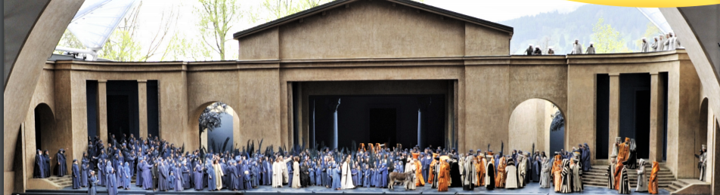

The enthusiastic singing was a highlight as well as the devotions by Pastor Peter Laihia. We thanked Pastor Peter for his leadership as our zone councillor as he returns to Finland and wished him God’s blessings. Our offering of just over $520 went to the Zone Project of Lutheran Media Mission. Lunch and fellowship rounded out the day beautifully in the grace of our precious Lord and Saviour.

LWQ Wide Bay-Burnett Zone Fellowship Day Thursday 20th October 2022
Theme for the day “Prayer”

The morning began with a welcome cuppa followed by the opening welcome and devotion led by the President of Hervey Bay Guild, Denise Hatch.

The day was inter dispersed with the singing of songs based on the theme of Prayer.
At short notice Carolyn Murdoch, who is a pastoral care worker for Lutherans, and Suzanne Hall, a hospital chaplain, both having completed the CPE course gave some of their thoughts and experiences in the various callings eg. Preparing yourself for visits, relying on the Holy Spirit to guide you, while speaking with all people, including persons of non-Cristian beliefs. They encourage others interested in this work of reaching out and sharing the good news to complete the CPE course. Then followed a time for questions. Denise conducted a short bible quiz for everyone to participate in, followed by Shirley entertaining us by reading some interesting and entertaining poems based on prayer. Avalon Hall LWQ Secretary sent greetings.

We were further entertained by the St. James Lutheran Children’s Choir. These children not only inspired us with their singing but portrayed their happiness and enthusiasm in their performances. A skit presented by the Hervey Bay ladies set in the 60-70’s dressed accordingly, hats, glove, bags etc. centered on a roving reporter asking each lady her views and how she saw “Prayer” as part of her life. Well done ladies.
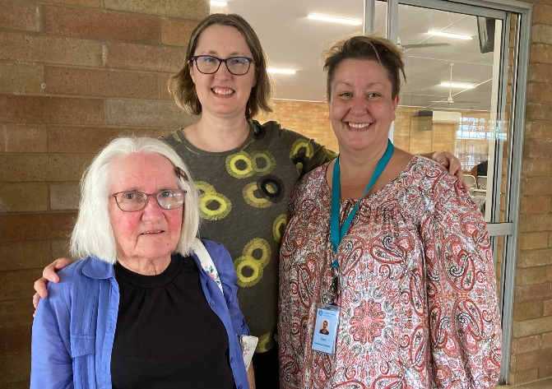
Lunch time was a great time to catch up and make new friends while enjoying the delicious spread provided by the local ladies for a small donation. The afternoon guest speaker, Kara Glover from the Fraser Coast Hospice, was an inspiration to all as she related how this all began in 2018. And how it is such a great facility where they care for people in their last days of life with love and dignity. The offering for the day was divided equally between Kairos a prison support group and Fraser Coast Hospice.
Photo L-R: Joy Baltzer. Suzanne Hall, Guest Speaker-Kara Glover.

The day concluded with a devotion led by Leona Brindley and the singing of “Prayer of Peace”.
Nola Zerner thanked the members of Hervey Bay for the programme they prepared and presented as well as the tasty foods we enjoyed throughout the day. Nola also prayed for the safety for all on their homeward journey.

Many thanks to the ladies of St. James Lutheran church Hervey Bay. A last cuppa before saying Good Bye then homeward bound. Reporter: Joan Yappa
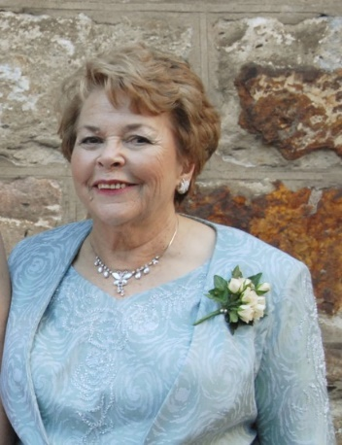
Brisbane North and Sunshine Coast Zone have lost our very faithful member ESTHER BELL-JONES formally of Nambour, late Bridgeman Downs, Qld. 10/1/1939 – 10/6/2022 aged 83.
Esther was a retired legal secretary and gave of her skills wherever and whenever needed. Esther served on every level of Lutheran Women, National, Qld State, Zone and also her home congregations. She always had encouraging words and notes for others she worked with. I feel sure we still keep those treasured notes close at hand. She served on the Zone Committee for many years. That shorthand note book could be seen in her hands at every meeting. Esther was a much loved and respected member of Lutheran Women who gave willingly of her time and talents. She also served on the organising committee of World Day of Prayer. Esther will be sadly missed by all as she now joins with her sister saints to be with her Lord.

NEWSLETTER INFORMATION
Editor: Pam Flesser, 26/23 Blackwood St., MAROOCHYDORE 4558
pnpfless@bigpond.net.au Ph 0416 203 433
Format for material: MS WORD DOCS and high resolution photo, Please.
Deadline for July 2023 Issue ……30th June 2023

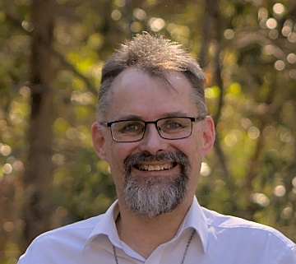
Pr Martin Scharnke is the new Qld advocate for ALWS. Martin is happy to be present at your zone Rallies/Fellowship days or just come and talk at your meetings, schools etc. or information on providing emergency reliet. You can contact him on 1300 763 407 and the faithful staff will be pleased to take your call and answer your questions. Martin remains on the roll of Pastors and is able to fullfill your needs to lead, preach or preside at Holy Communion, where this is needed on his visits.

Please prayerfully consider taking on a position on the LWQ EXECUTIVE
All positions of LWQ will be declared vacant at Convention in May 2023.
The nominations Committee will be seeking ladies to fill these positions. Please prayerfully consider taking on a role with the LWQ Executive, and get in contact if you (or someone you know) feels called to assist/help LWQ to continue God’s Mission work.

They would love to hear from you.
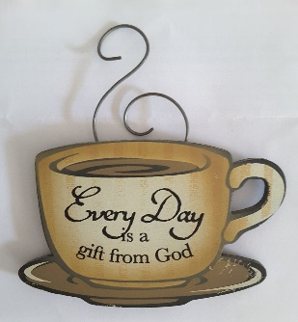
Lyn Klinge Ph 0418 188 212
Lois Schultz Ph 0488 235 138
Jill Scheffe Ph 0417 604 434

FROM YOUR PRESIDENT:
Shirley Horrigan sends greetings to all and may God watch over each one. I pray that many of us will be able to attend Retreat / Convention

Men’s Program Retreat/Convention 2023
Day/Time | What is happening | Person Responsible
Friday Evening (approx. 6.00pm) | Go to Hotel for dinner | Pastor Peter and David Klinge
Friday pm (after dinner)  Return to Convention centre 2nd area | Pastor Peter will talk on Creation Evangelism, featuring the Creation museum in the U.S.A. | Pastor Peter
Saturday 8.30 - 9.00 am | Bus Trip departs | David Klinge/Adrian Shepley
9.45 | Morning tea | Yandina
12.00 noon  1.30 pm  4.30 pm | Tour places of interest  Lunch wherever  Caloundra Air Museum  Leave to return to camp | David Klinge
Sat. 6.00pm | Dinner & Program  Main dining hall
Sunday  10.00 am  10.30 am  12.00 noon | Breakfast then. Free time Morning tea.  Worship Service  Lunch
1. 30 pm | Depart
Bus cost for Saturday $10.00 to be paid to David Klinge. Correct change would be preferred.

LWQ Combined Retreat/Convention - Program 19-21May 2023

Day | Time | Program
Friday | 3.00 pm | Arrivals
Friday  Evening | 6.00 pm  9.30 pm | Dinner-Praise Time-Activities-_Closing Devotion Camp Song  Supper- Bedtime own choosing be mindful of others.
Saturday  Morning | 7.00am 7.30 am  8.30 am  10.00 am  10.30 am  12.m/day | Devotions around the complex  Breakfast  Devotion-Praise time-Bible Study  Morning Tea  Convention session 1:. Greetings-Apologies-Introduction Zone Presidents-Minutes of last Convention- Announcements of nominations.  Lunch
Saturday afternoon | 1.30 pm  3.00 pm  3.30 pm  6.00 pm  9.30 pm | Praise Time- Guest Speaker “The God Squad”  Afternoon tea with guests  Reports: LWQ President Shirley Horrigan-  Treasurer Leanne Warbrooke - LWA President- LCAQD Bishop- LWQ Newsletter Pam Flesser-  General business/proposals- Election of Office Bearers-  Appointed By LWQ Executive -Counsellor  Vote of thanks to retiring LWQ Executive-  Unfinished business to Sunday morning- Free time.  Retreat/Convention Dinner- Short devotion- Praise time- Grace.  Guest Speaker  Community singing-Prayer benediction-  Supper Bedtime own choosing being mindful of others
Sunday | 7.00 am  7.30 am  8.45 am  10.00 am  10.45 am  12.00 m/d  1-2.00 pm | Devotions around complex  Breakfast/ commence pack up  Praise time - Unfinished business-Activity  Morning tea  Worship and installation of LWQ Executive  Lunch- Announcements- Final Retreat Song  Departures
Tea/Coffee/ biscuits etc. in another hall for evening supper or anyone wanting an early cuppa.

REGISTRATION FORM LWQ RETREAT/CONVENTION Fri 19th Sat 20th Sun 21st May 2023
Theme: COURAGE – “Courage To tell our story” 1 Corinthians 16: 13
Maroochy Waterfront Camp and Conference Centre
David Low Way, Maroochydore. Q.

Please complete this form and send to WMZ Treasurer (address below)
Surname | Given name
Address
Phone
Next of Kin-name | Phone
Email
Guild/Fellowship
Diet/Health issue
Men’s Registration
Surname | Given Name
Diet/Health issues
Phone

Registration Description – Please fill in all that apply | Cost | Total
Full Registration Friday to Sunday (incl all meals & Accommodation | $300.00
Sat only – (Morning Tea, Lunch, Afternoon Tea & 2 course Dinner)  If off site accommodation and NO breakfast and all other meals Friday-Sunday | $ 80.00  $160.00
Men’s package (incl. Accom. Fri. & Sat. night breakfast, Morn/tea, aft/tea. 2 course dinner, Sat night, Breakfast, M/tea & lunch Sunday  Note (This does NOT INCLUDE DINNER Fri night or lunch on Saturday) | $230.00
Men leave for day trip Saturday lunch is not included.
Men’s Buss excursion - Saturday | $10.00
Late fee If paid after 05.05.23 | $20.00
TOTAL COST
Please note if cancellation occurs $20.00 Fee is non refundable
Registration required by…05/05/23……Latest
Payment Details:-
Direct Credit to: LWQ - BSB 704 942 Account No 100 066 968
Cheque or Money Order payable Lutheran Women Queensland Please post / Email signed form and Payment details to: Mrs. Leanne Warbrooke, 9 Merrick Street, Wishart QLD 4122 (Phone 0488 128 823)
OR Scan and email to: warbrooke05@bigpond.com

I/ we………………………………………………………………………………. do hereby apply to participate in the LWQ/WMZ RETREAT/CONVENTION AT Maroochy Waterfront Camp and Conference Centre, David Low Way Maroochydore
19th – 21st May, 2023. I declare that LWQ/ WEST MORETON ZONE officers and all others concerned with the Retreat/Convention be free from all responsibility whatsoever for all accidents or illnesses resulting from my participation in any activities with the Retreat/Convention. Furthermore, I promise to conduct myself as a Christian and willingly submit to the rules set down for the Retreat/Convention. I DO / DO NOT agree to my photo being used in LWQ RETREAT/Convention PROMOTIONAL MATERIALS.
SIGNATURE…Female………………………………………………………Date…………/………/2023

Male…………………………………………………………………………… Date……… /…… / 2023
NOTE:All bedding / linen supplied including towel. Bring a pillow each room has ensuite / Fridge
Please indicate if double bed is required …… shower chair…Y / N…………….
My preference to room share with…………………………………………………………..

